KUWAA MISSION
ADOPT A CHURCH – ADOPT A SCHOOL PROGRAM

The Kuwaa Mission (KM) is starting a new program to assist the people in these remote villages to build and/or repair the churches and schools in their village.

Many of the facilities were heavily damaged by the civil war that ravaged the country. Many more have fallen apart due to the heavy rains that they experience and the structure in no longer in existence. This area is also being impacted by climate change as the rains are becoming much heavier and the rainy season lasting longer; all adversely impacting their ability to grow enough food to feed themselves.

Some villages, those close to the main road, have been able to rebuild their churches and schools but most villages are a several hour walk, motorbike ride if lucky, from the end of the road. Just getting to the end of the road over a rutted, muddy road with old log bridges that are also falling apart makes delivery of materials a difficult challenge, to put it mildly.

We would like individuals or churches to adopt a village church or school and be responsible to pray for the village and support the people by providing funds for the rehabilitation of the facility. This would mean much to the people. Even more so would be the sending of volunteers over to the Kuwaa area to work with the people in the reconstruction of the buildings. This would give the volunteers an experience of a lifetime, the chance to live and visit with the people, and to give them hope. The exact village will be determined between the adopting church, the KM and Rev. Paye who is the Lutheran pastor assigned to the Kuwaa area.

The cost would depend on the size of the village which determines the size of the facility. Typically a small church would cost about $15,000 usd and school about $25,000 usd. Many of the materials can be gathered from the surrounding area but much needs to be brought in by vehicle from Monrovia. Transportation is the single largest expense. Members of the KM board are willing to meet with your congregation to help facilitate this process and provide additional detailed information.

On the other side is a photo of a typical school and church that is in need of repair. Some villages have more than one school building due to several different grades and the increasing number of students, just like in America!! Some facilities are in better shape, many in much worse condition.

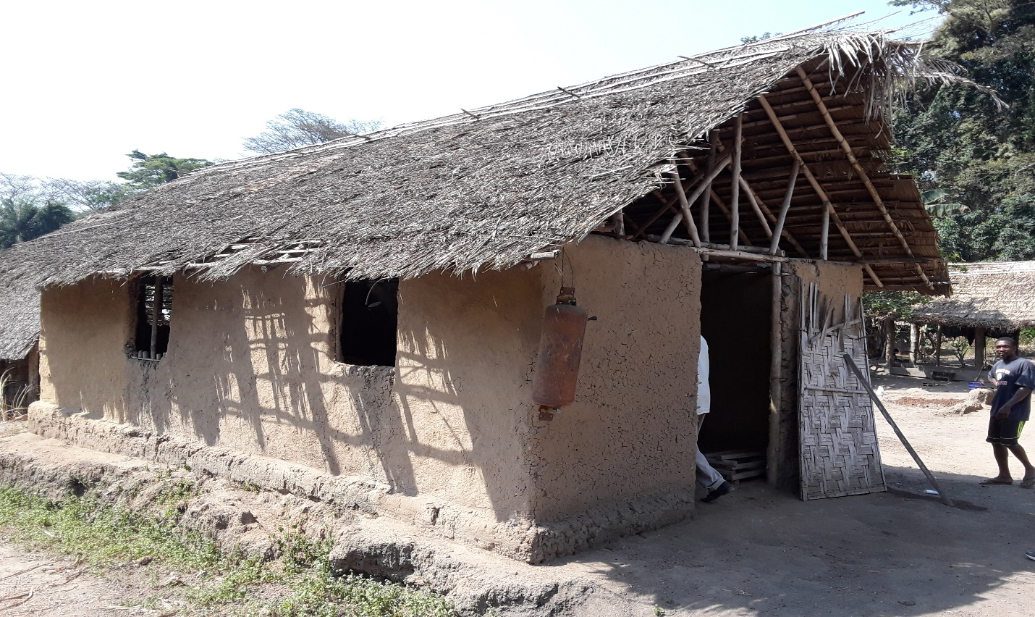

Lutheran Church in Gatema

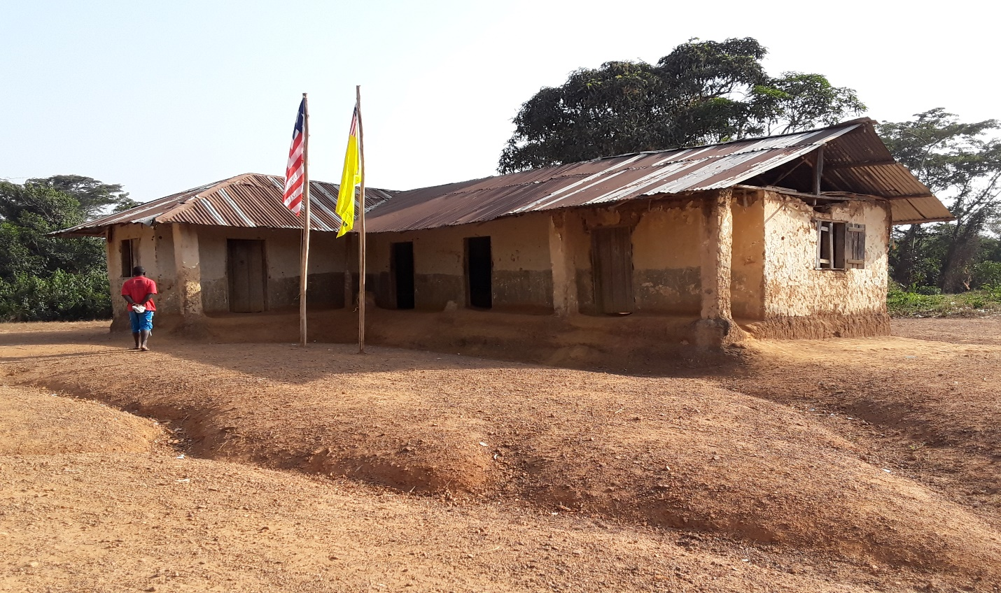

School in Kondesu

